Software Design and Architecture
Assignment Lab
Joseph george samy | 202200552
Michel Magdy | 202200620
Joshwa Samir | 202200754
Youssef Emad | 202200649
Kirolos Mina | 202201086
Github Link: https://github.com/ENGjoseph/SoftwareDesignAssignment.git

- Online_Game_Inventory_System
- Description:
allows players to create, duplicate, and manage different types of game items such as swords, guns, and potions.
The system demonstrates how design patterns can improve code organization, flexibility, and performance.

- The program is structured into several components:
- Item interface: Defines common behavior for all items
- Concrete classes: (Sword, Gun, Potion) implement the Item interface
- ItemFactory: Responsible for creating item objects
- Inventory class: Manages all items using a Singleton pattern
- Online_Game_Inventory_System: Runs the program and demonstrates functionality

- Design Patterns Used:
- Factory Pattern
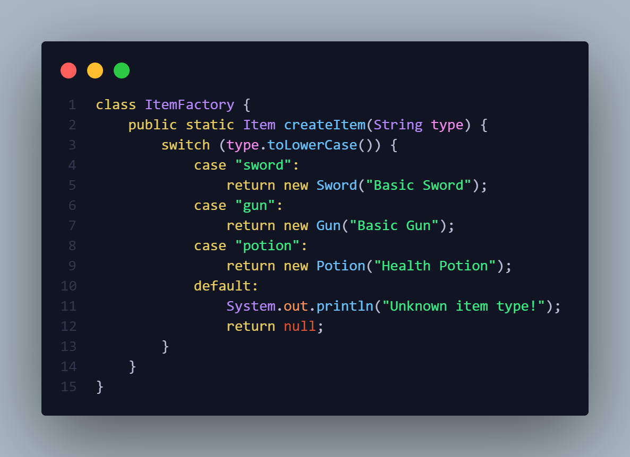
  - The Factory Pattern is used to create objects without specifying the exact class.
It is implemented in the ItemFactory class, which generates different types of items based on user input.

- Prototype Pattern
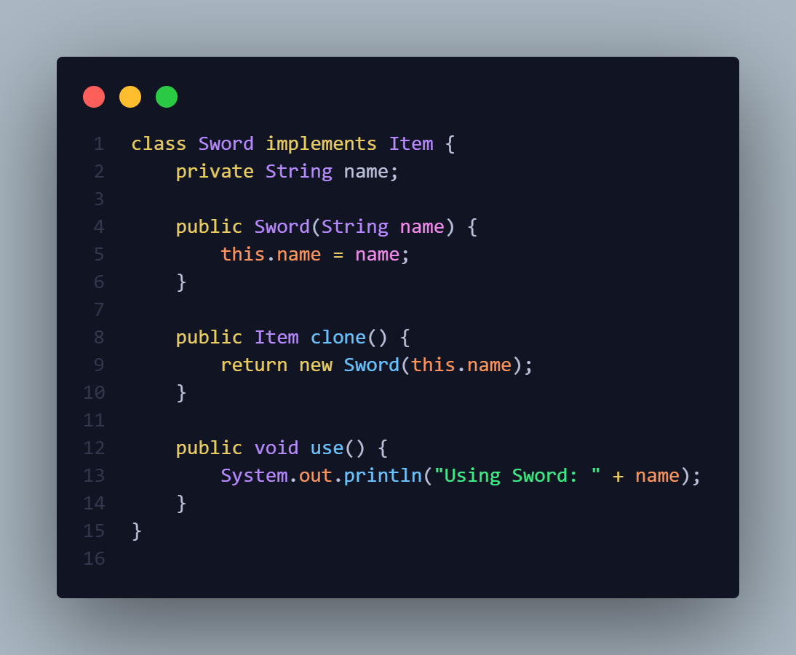
  - The Prototype Pattern is used to create new objects by copying existing ones instead of creating them from scratch.
It is implemented through the clone() method in each item class.

- Singleton Pattern
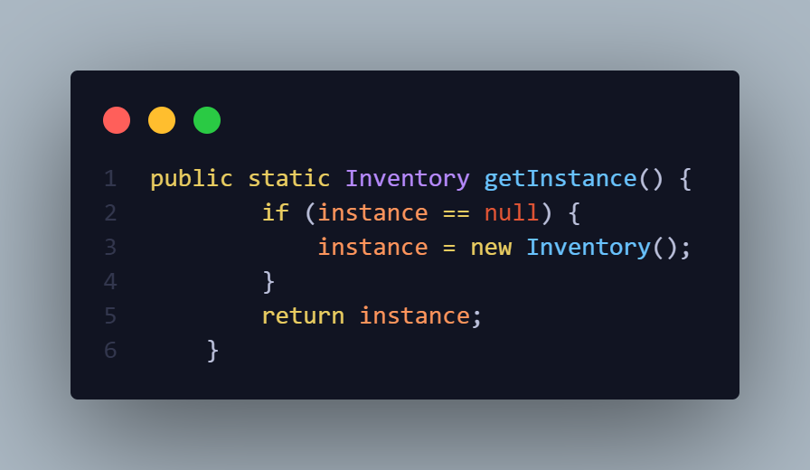
  - The Singleton Pattern ensures that only one instance of a class exists throughout the program.
It is used to manage the inventory system.
- Justification
  - Factory Pattern: to reduce tight coupling between the client code and object creation.
It allows easy addition of new item types without modifying existing code, making the system more flexible and maintainable.
  - Prototype Pattern: The Prototype Pattern was used to improve performance when duplicating objects.
Instead of creating a new object from scratch, the system can clone an existing one, which is faster and more efficient.
  - Singleton Pattern: The Singleton Pattern was chosen to ensure that there is only one inventory system managing all items.
This prevents inconsistencies and ensures centralized control over the data.

